CASTRO NEIGHBORHOOD
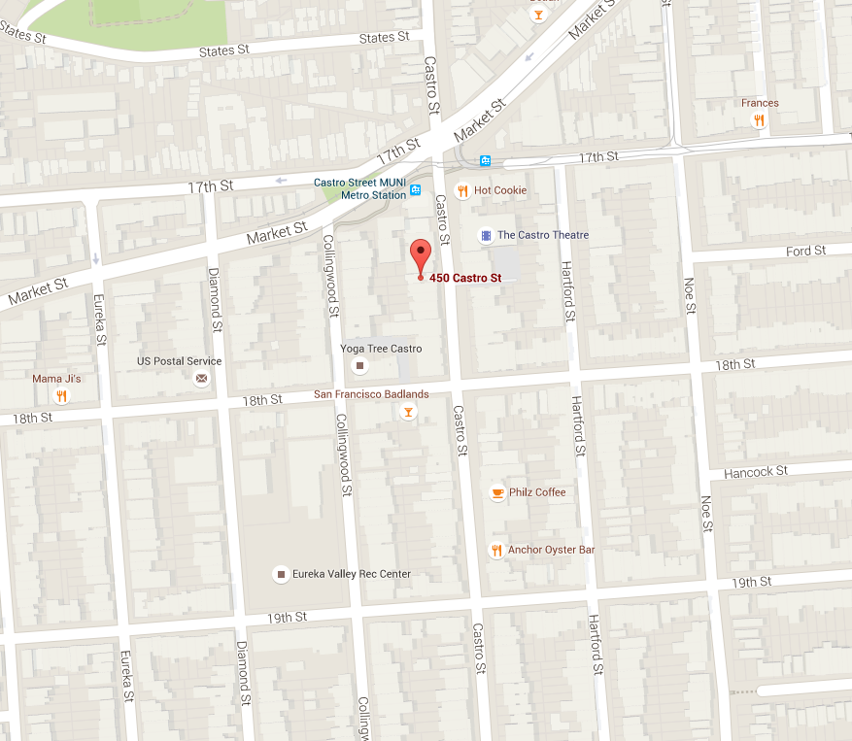
* Filming along the sidewalks within the red grid above.

